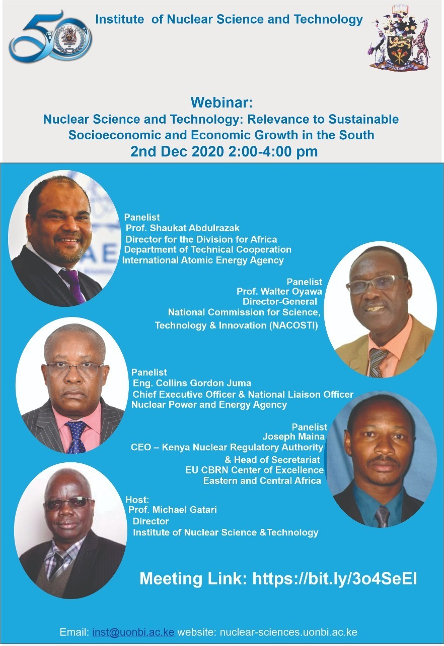

**INST Webinar: Nuclear Science and Technology**

On Wednesday, 2nd December 2020 from 2:00 to 4:00 PM:

Investment in research for development of a strong human resource base is a well-known and appreciated foundation for sustainable development in the North. In Science the multidiscipline diversity of peaceful applications of nuclear science and technology offers a solution for research capacity building globally. However, it remains unappreciated and a myth to many, including the academia, in Sub-Sahara Africa and by extension in our country. The ripple effect is inhibition of the youth being able to identify its importance in their career development.

This webinar will bring together the Representatives of our Government Institutions that are mandated to promote nuclear Science and technology in Kenya and the Regional Representative from International Atomic Energy Agency to discuss and demystify the noble field in Nuclear science and Technology. This has come at an opportune time when University of Nairobi is celebrating 50 Years of its existence and great achievements in the region.

You are all welcome!

The Link is shown on the following flyer



Prof. Michael Gatari