
UNIVERSITY OF NAIROBI
STUDENTS’ ASSOCIATION INDEPENDENT ELECTORAL COMMISSION

UNIVERSITY OF NAIROBI STUDENTS’ COUNCIL AND CAMPUS ASSOCIATIONS READJUSTED ELECTIONS TIMELINES 2020

No | Task Name | Duration | Date(s)
 | Announcement of Students Association Elections | 1 day | Wednesday, 7th October, 2020
 | Recruitment of Returning Officers and Presiding Officers | 5 days | Thursday, 8th October, 2020 to Monday, 12th October, 2020
 | Training of Returning Officers and Presiding Officers | 1 day | Friday, 16th October, 2020
 | Sensitization and voter education | 22 Days | Monday, October 12th to Monday, 2nd November, 2020
 | Submission of students register of voters by Deans/Directors to the Electoral Commission | 1 day | Wednesday, 14th October, 2020
 | Display of students register of voters on election portal | 7 days | Monday, 26th October, 2020 to Sunday, 1st November, 2020
No | Task Name | Duration | Date(s)
 | Submission of names of aspiring teams and campaign symbols to the Electoral Commission for:  - Campus Students’ Association Elections  - Students’ Council Elections | 1 day | Monday, 26th October, 2020
 | Publication of approved team names and symbols | 1 day | Wednesday, 28th October, 2020
 | Clearance for access to nomination papers and Code of Conduct from the Electoral Commission for:  - Campus Students’ Association Elections  - Students’ Council | 5 days | Thursday, 4th November, 2020
 | Nomination for:  - Campus Students’ Association  - Students Council | 1 day | Monday, 9th November, 2020
 | Publication of successfully nominated aspiring teams | 1 day |  | Tuesday, 10th November, 2020
 | Campaign period | 7 days |  | Start Tuesday, 10th November, end Monday, 16th November, 2020
 | Submission of list of agents for aspiring teams to the Electoral Commission for accreditation for:  - Students’ Council Elections | 1 day |  | Monday, 12th November, 2020
 | Voting for Campus Students’ Association Teams and Students’ Council Electors | 1 day |  | Wednesday, 18th November, 2020 8.00 a.m. to 5.00 p.m.
 | Counting, tallying and announcement of results |  |  | Immediately after conclusion of voting on 18th November, 2020
 | Swearing in of Campus Students’ Association Teams | 1 day |  | Thursday, 19th November, 2020
No | Task Name | Duration |  | Date(s)
 | Verification and publication of Students’ Council electors by the Electoral Commission | To be determined
 | Presentations by aspiring teams to the electors for the Students’ Council Election | To be determined
 | Election of Students’ Council | To be determined
 | Swearing in of the Students’ Council Winning Team | To be determined

Note
1. Nos. 17, 18, 19 & 20; The Independent Electoral Commission to communicate details later.
2. The Commission may make necessary clarifications and corrections from time to time during the election process.

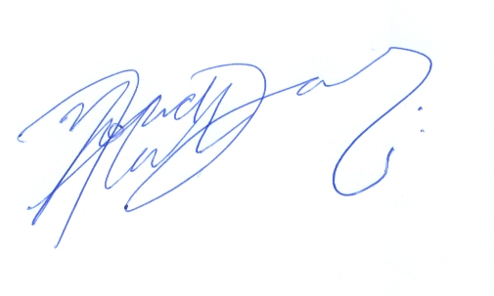
PROF. MOHAMUD A. JAMA DATE: NOVEMBER 4, 2020
CHAIRMAN
UNSA INDEPENDENT ELECTORAL COMMISSION

Copy:

Vice Chancellor
Deputy Vice Chancellor (AA)
Deputy Vice Chancellor (FP&D)
Deputy Vice Chancellor (HR&A)
Deputy Vice Chancellor (RIE)
All Principals
Deputy Principals
Directors; ODeL Campus, Graduate School, Mombasa & Kisumu Campus
Dean of Students
Deans & Directors
Director, SWA
Director, ICT
Director, Security & Safety Services
All Students

Registrar, Academic Affairs

